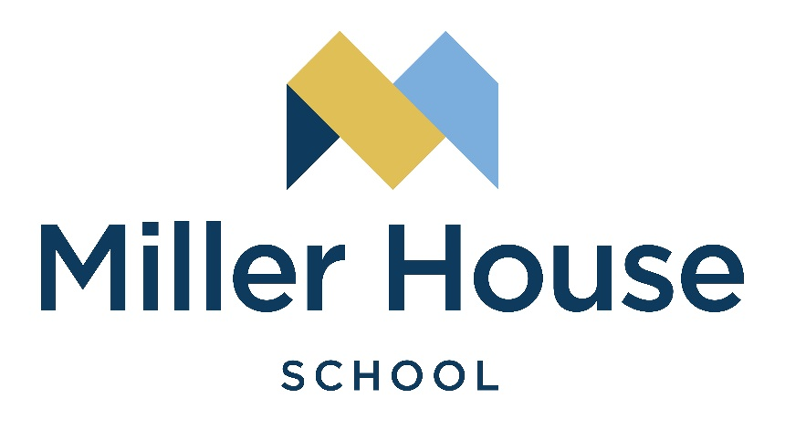
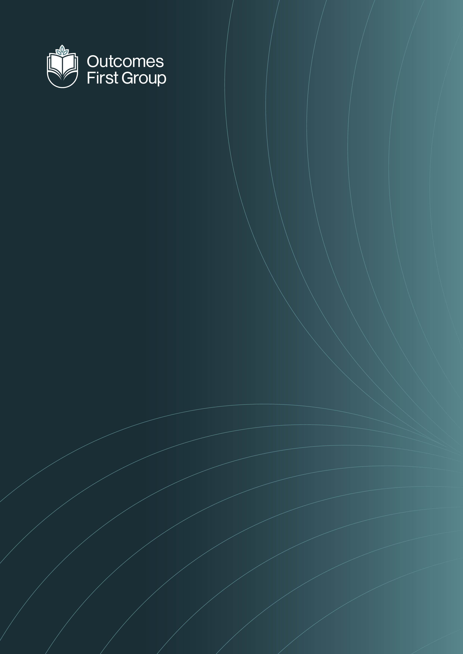


Curriculum

Policy

CURRICULUM POLICY

To be read in conjunction with:

- Assessment Policy
- Accessibility Policy & Plan
- SEND Policy
- Educational Visits Policy
- Careers Education and Guidance Policy
- Marking and Feedback Policy
- SMSC Policy
Policy Review Date: September 2026

Contents

- Introduction
- Curriculum Intent
- Curriculum Implementation
- Curriculum Impact

Introduction

Our school moto is …
We Nurture Dreams
To Build Futures
Through Care Compassion
Quality and Impact

School Context

Miller House School caters to boys and girls aged 11–16 with a range of complex needs, primarily Social, Emotional and Mental Health (SEMH). Many pupils also have communication difficulties, ADHD, high anxiety, specific learning difficulties and experiences of early trauma. All pupils have an Education, Health and Care Plan (EHCP) and come from multiple local authorities. Many have experienced disrupted education and challenges in accessing mainstream schooling.

Curriculum Vision

The curriculum is broad, balanced, and personalised to meet the unique needs of SEMH learners. It includes all planned learning experiences — both formal lessons and informal activities — and is designed to support:
- Academic achievement through core subjects including English, maths, science, and literacy
- Social and emotional development through PSHE, emotional literacy, therapeutic support, and life skills
- Personal growth through spiritual, moral, social, and cultural development (SMSC) and cultural capital

Curriculum Aims/intent

All pupils are supported to become:
- Successful Learners – achieving the best outcomes for their individual abilities
- Confident Individuals – developing resilience, self-awareness, and social skills
- Responsible Citizens – learning to form positive relationships and contribute to their communities

Our curriculum promotes emotional literacy, self-esteem, and confidence. Teaching is differentiated, empathetic, and delivered in a trauma-informed, nurturing environment using strategies such as AAD and TIP to meet SEMH needs.

Curriculum Design

The curriculum will:
- Be sequential across year groups
- Include overlearning to support long-term retention of knowledge and skills
- Offer personalised pathways to ensure each pupil achieves their best possible outcomes
- Provide enrichment opportunities beyond the classroom that develop SMSC, British Values, and cultural awareness

Pupil Entitlement

All pupils, regardless of ability, background, or need, are entitled to a high-quality, ambitious, and personalised education that challenges and motivates them while supporting their social, emotional, and mental health development.

Addressing Special Educational Needs

Before admission, staff receive relevant information, including the EHCP, educational history, medical details, and social/emotional needs. On arrival, pupils complete baseline assessments (therapeutic and academic), which inform individual targets and plans, including education, support, and risk management.

Accountability

This policy complies with Independent School Standards Part 1: Quality of Education, paragraph 2(1)(a).

Curriculum Implementation

Curriculum Offer | Curriculum Delivery
Academic  The more formal and semi formal pathways are drawn upon to deliver our unique curriculum that is tailored to meet the needs of our student cohort. With having the 2 strands we can be flexible in our offer ensuring the students are stretched and challenge but not set up to fail.  The students of Miller house have often missed essential building blocks in early develop due to early trauma and missed education. Our curriculum is flexible and with the spiky profiles of our children we can draw from each strand, meeting the needs and academic potential of all students. | Academic Timetable  Structured and systematic approach with clearly defined lessons. Can follow a secondary model or semi formal thematic delivery. All have access to specialist staff and learning environments.  Learner-Initiated and Adult Led Teaching  A flexible approach with teaching input delivered in short and diverse sessions.  Thematic Learning  Integrated approach with cross-curricular opportunities around a focused theme or overarching question. Thematic learning space to support and enhance delivery.
Therapeutic
Individual and group interventions are offered and embedded across the curriculum with a structured, well-informed environment that is designed to always support pupils’ health and well-being.
Creative
Imaginative, problem solving and expressive approach, practice and originality.
Experiential
Providing new and rich opportunities for pupils to have experiences and explore possibilities.
Recognition and nurture of interests, ambitions
and talents. Opportunities to support and enrich.

At Miller House School, we are committed to ensuring that every pupil has equal access to education and the opportunity to reach their full potential. Our curriculum is sequential, purposeful, and designed to promote independence.

Embedded within the curriculum is the Miller House Passport to Independence, which tracks and records the development of essential life skills. Teaching and learning are tailored to suit the learning styles of our students, with lessons designed to be creative, practical, and enjoyable.

Support, Intervention, and the Wider Curriculum
Pupils will have access to therapeutic support from the therapy team. Individual pupils will also have specific interventions to support their needs, this can include, extra literacy support, pastoral support or emotional regulation. There is a focus on life skills and being able to socialise appropriately and integrate into the world around them.

Sensory Considerations

We recognise that many pupils experience sensory difficulties, which can affect learning and behaviour. Staff are mindful of sensory needs in all teaching and help pupils develop strategies to manage these challenges. This ensures that every student can access the curriculum and achieve their outcomes.

Sensory support strategies include:
- Clearly displayed visual timetables and individual timetables on desks
- Keywords and topic vocabulary for reference
- Clearly labelled resources
- Small-step instructions and scaffolding
- Gaining pupils’ attention by name
- Individualised processing time
- Consideration of visual and auditory stimulation in the classroom
- Designated regulation spaces (e.g., distraction-free rooms, sensory rooms)
- Active support from teachers and teaching assistants
- Breaking learning into small chunks with sensory breaks where needed

The learning environment is designed to be safe, inviting, and enriching. Movement is incorporated into lessons where necessary, and alternative seating arrangements support concentration. Kinaesthetic and practical learning experiences are prioritised to engage students fully, with joy and fun embedded in every lesson.

Therapeutic Support and Intervention

All staff are trained in Trauma-Informed Practice (TIP) and our autism strategy, Ask, Accept, Develop (AAD). This enables therapeutic approaches to be embedded across teaching and learning.

Some pupils may require additional support from the therapy team, either individually or in small groups. Support is available from:
- Occupational Therapy
- Speech and Language Therapy
- Psychotherapy

Miller House School is committed to meeting the needs of each pupil as outlined in their EHCP.

Specialist Staff

Our staff are trained to deliver the curriculum while understanding the therapeutic needs of our pupils. Staff collaborate with multidisciplinary teams, including speech and language therapists, occupational therapists, psychotherapists, and mental health professionals, to provide a holistic and personalised package of support.

Interventions

Pupils with gaps in learning receive targeted interventions in areas such as numeracy, literacy, phonics, reading, writing, or readiness to learn. Teachers monitor and oversee interventions to ensure progress and achievement of individual outcomes.

Reading is a priority. We assess reading through Accelerated Reader and other tools to provide targeted support. Reading is made enjoyable through shared activities, classroom integration, and dedicated reading spaces, fostering lifelong skills and a love of reading.

Social, Moral, Spiritual, and Cultural Education (SMSC)

All pupils receive SMSC education, respecting the integrity of all faith backgrounds and promoting understanding of diverse spiritual traditions. Pupils are encouraged to differentiate between right and wrong, value themselves and others, and understand the importance of rules and community.

All curriculum areas contribute to pupils’ character development, celebrating achievements and promoting cultural awareness.

Fundamental British Values

We actively promote:
- Democracy and understanding of decision-making processes
- The rule of law and accountability of institutions
- Individual liberty, including freedom of belief
- Mutual respect and tolerance for others

These values are embedded across teaching, assemblies, PSHE, and school council participation.

Protected Characteristics and Equality

All pupils are valued and supported to achieve their potential, with curriculum opportunities reflecting positive role models from diverse backgrounds. We aim to reduce barriers to learning and promote inclusivity.

Staff recruitment, retention, and professional development adhere to Safer Recruitment principles and equality legislation, ensuring fair treatment regardless of age, disability, gender reassignment, marriage or civil partnership, pregnancy or maternity, race, religion or belief, sex, or sexual orientation.

Careers and Aspirations

From an early stage, pupils are introduced to a wide range of careers, linking learning to future opportunities. Classroom discussions, role models, and themed activities help pupils connect strengths and interests to possible career paths, broadening aspirations and fostering long-term motivation and purpose.

Miller House school Curriculum overview
KS3 & 4
CV
Academic
English Maths
Science PSHE/RSE
Humanities Music/Art/DT
PE ICT
Social and emotional
Horticulture Personal fitness
Forest School DoE
Horse riding Outdoor Ed
Swimming Catering
Forest School
Miller House Passport to independence

Levels & Quals
Functional Skills
ASDAN
AQA award
NCFE - careers

Enrichment
Biking
Lego Therapy
Offsite trips
Esports

KS4 Options
Hospitality Media studies
Horticulture ICT
Animal Care
Health and Fitness
Photography

Semi formal EHCP sections and subject that link

Cognition and Thinking

English
Maths
Keeping Safe

The world around us
PSHE
ICT
History
Geography
Science

Independence
Catering
Miller House Passport to independence
Enrichment
Physical wellbeing

PE
Forest School
Outdoor Ed
Creativity

Art
DT
Music

Miller House Curriculum Impact
Our School’s Curriculum will:
- Allow students to reach their full potential
- enable pupils to fulfil their potential
- meet the needs of pupils of all abilities
- have a supportive, therapeutic environment
- be accessible and give a full range of learning experience beyond statutory guidelines.
- prepare pupils to make informed and appropriate choices at points of transition
- help pupils develop lively, enquiring minds, an ability to question and argue rationally and an ability to apply themselves to tasks and physical skills
- Relevant to pupils and be engaging.
- help pupils to use language and number effectively
- help pupils develop personal moral values, respect for religious values and tolerance of other
- races’ beliefs and ways of life
- help pupils understand the world in which they live
- meet the social, emotional and behavioural needs of our pupils
- be prepared for the next steps such as college and adulthood.

At Miller House we have the two strands of curriculum and with the cohort of children teachers draw from each programme to inform the Miller House Curriculum. By adapting the national curriculum and building in life skills from the semi formal curriculum we meet the needs of all the children, they make good progress not just academically but also socially and emotionally to leave Miller House School with their desired outcomes ready for the next step in their educational journey.

Miller House Curriculum
Intent
At Miller House, our curriculum is designed around the individual needs, starting points and experiences of our pupils. Many of our students arrive with disrupted education, gaps in knowledge and low confidence in their academic ability. Our aim is to provide a curriculum that rebuilds engagement with learning, develops core skills and prepares students for meaningful next steps in education, training or employment.
Recognising that students learn at different rates, we have removed the traditional age-related expectations within Mathematics and English. Instead, we use a skills progression model, allowing students to develop and secure learning at a pace appropriate to them. This approach ensures that gaps in learning can be addressed while enabling students to build confidence and experience success.
Progression documents support teachers in tracking learning and building evidence towards recognised qualifications. Students are supported to achieve either Entry Level or Functional Skills qualifications in English and Mathematics, ensuring that all learners leave Miller House with meaningful and recognised outcomes. Alongside this pathway, we maintain a formal academic curriculum for students who demonstrate the readiness and ability to progress towards GCSE qualifications.
Across the wider curriculum, long-term plans have been carefully designed for each year group in Key Stage 3. These plans expose students to a broad range of subjects and vocational areas that link directly to potential Key Stage 4 option pathways. This allows students to explore their interests, develop practical skills and begin to understand how learning connects to future careers and independence.
Our curriculum aims to:
- Re-engage students in education and rebuild confidence in learning
- Develop essential literacy and numeracy skills
- Provide meaningful, real-life contexts for learning
- Introduce vocational pathways that support future aspirations
- Prepare students for independence, further education and employment

Implementation
The Miller House curriculum is implemented through a structured yet flexible approach, ensuring that learning is accessible, engaging and responsive to student needs.
In English and Mathematics, teaching is guided by clear skills progression frameworks rather than age-related expectations. Baseline assessments identify each student’s starting point, enabling teachers to plan learning that closes gaps and builds secure foundations. Students can revisit concepts where necessary, ensuring that knowledge is embedded before moving forward.
Differentiation is a key feature of classroom practice. Teachers adapt learning through:
- scaffolded tasks and modelling
- practical and visual learning approaches
- structured support and targeted interventions
- varied challenge levels to support mixed attainment groups
Assessment is ongoing and formative, allowing staff to track student progress through the progression frameworks and gather evidence towards Entry Level, Functional Skills or GCSE pathways.
The wider curriculum is delivered through carefully planned long-term subject maps that run across Years 7, 8 and 9. These plans ensure coverage of key knowledge and skills while linking learning to potential vocational and academic pathways in Key Stage 4.
Subjects across the curriculum provide opportunities for students to develop practical and transferable skills. Vocational links include areas such as:
- Catering and hospitality
- Horticulture and forestry
- Health and fitness
- Animal care
- ICT and media
- Photography and creative arts
Learning is designed to be hands-on and experiential, helping students see the relevance of their education and supporting engagement, particularly for learners who may have previously struggled within traditional academic environments.
Staff also prioritise the development of personal, social and independence skills, recognising that these are essential for successful transitions beyond school.

Impact
The impact of the Miller House curriculum is seen in the progress students make from their individual starting points, both academically and personally.
Students develop improved confidence in their abilities as learners and begin to experience success in areas where they may previously have struggled. The flexible progression model allows students to secure key skills in English and Mathematics, leading to recognised outcomes through Entry Level, Functional Skills or GCSE qualifications.
Through exposure to a broad and purposeful curriculum in Key Stage 3, students are able to make more informed choices about their Key Stage 4 pathways. The introduction to vocational areas helps students identify interests, strengths and potential career aspirations.
As a result of the curriculum, students leave Miller House with:
- improved literacy and numeracy skills
- recognised qualifications appropriate to their ability
- increased engagement with learning
- greater confidence and resilience
- practical skills linked to real-life contexts
- clearer pathways into further education, training or employment
Ultimately, the curriculum supports students in developing the knowledge, skills and independence they need to successfully transition into the next stage of their lives.



